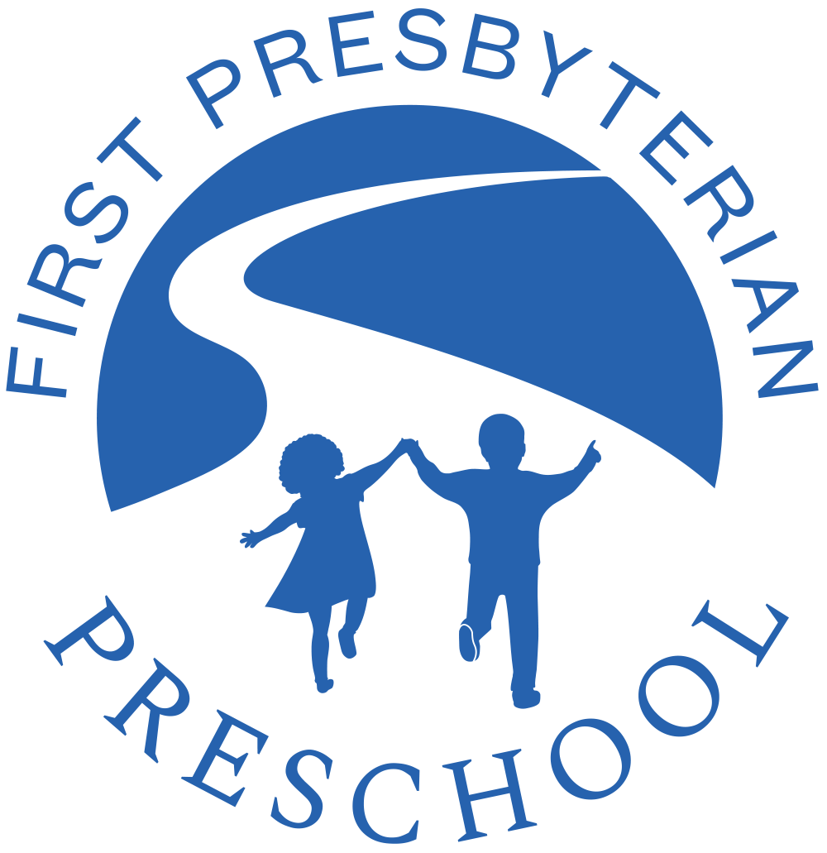

First Presbyterian Preschool Annual Tuition Policy

First Presbyterian Preschool is a non-profit organization basing budgeting decisions on full enrollment. We rely on annual tuition collection for operating expenses. Students are enrolled in our program when parents complete the following steps:
- Complete an application for enrollment;
- Receive confirmation that their child has received a space in our program and complete the electronic registration confirmation form;
- Submit the first tuition payment due on April 12, 2019

By completing the enrollment process it is agreed that annual tuition is non-refundable and non-transferable. I understand that my obligation to pay the annual tuition and fees for the full academic year is unconditional and that (except as noted below) no portion of such fees or outstanding annual tuition will be refunded or canceled in the event of absence, withdrawal, or dismissal from First Presbyterian Preschool. The payment of annual tuition and fees in installments does not deem this to be a fractional contract and once a child is enrolled (as outlined above), parents are financially responsible for the student and obligated to pay the full annual tuition charges.

If it becomes necessary to withdraw a child from the Preschool due to relocation outside of the Metropolitan Atlanta Area, 50% of the unused annual tuition is refundable if and only if all of the following conditions are met:
- Withdrawal of the child is necessitated by the family’s moving outside of the Metropolitan Atlanta Area (Fulton, DeKalb, Gwinnett, Cobb, Clayton, Butts, Cherokee, Douglas, Fayette, Forsyth, Henry, Newton, Rockdale and Walton counties); AND
- Written notice is given 30 days prior to the withdrawal; AND
- The classroom opening is filled within the 30 day notification period: AND
- The corresponding classroom is at full capacity.

Upon meeting these conditions, a refund equivalent to 50% of the unused annual tuition will be mailed to your forwarding address.

Other than the circumstance outlined above, all annual tuition payments received by First Presbyterian Preschool (including any prepayments made before the applicable due dates) are non-refundable and non-transferable. A registration fee is due with your application form.

Annual tuition payments made past the annual tuition payment dates outlined on the Annual Tuition Payment Options sheet should add a $50.00 late payment fee.

